**Troubleshooting for MAINTENANCE Mode**

Recently, many users encounter the issue that Micro:bit board doesn’t respond when connected to computer.

If the way you operate is correct, maybe you accidentally press the reset button and enter the Maintenance mode or lead to lose the firmware due to misoperation.

Plug in Micro:bit board, the“MAINTENANCE”drive appears. That means the program can’t be downloaded.  
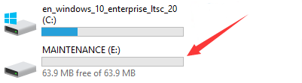

Note:

Download the **hex file** from this page to your computer.

Down load the latest firmware---0253:

[https://cdn.sanity.io/files/ajwvhvgo/production/5ecfa4d407a9d02e0f2e7fe192e5fa6a246f8621.hex?dl=0253_kl26z_microbit_0x8000.hex](https://cdn.sanity.io/files/ajwvhvgo/production/5ecfa4d407a9d02e0f2e7fe192e5fa6a246f8621.hex?dl=0253_kl26z_microbit_0x8000.hex )

1. After the latest firmware is downloaded, then drag it into the“MAINTENANCE”drive as follows, which makes Micro:bit come back to normal mode.

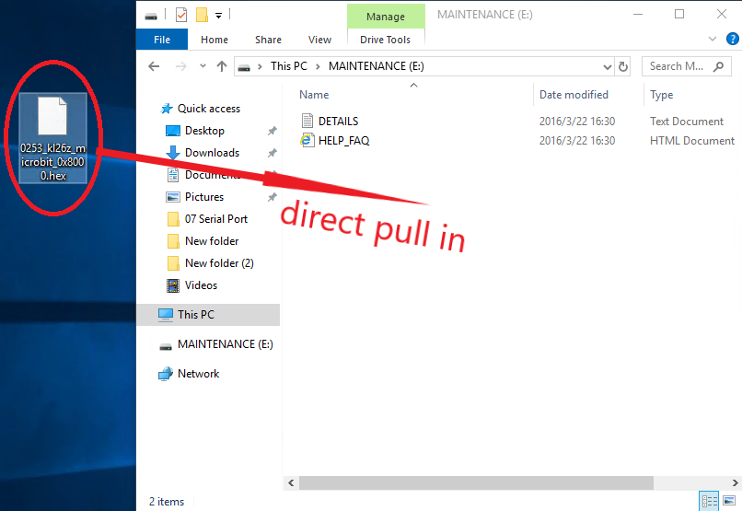

## ****How to avoid to enter“MAINTENANCE”mode?****

Make sure the Reset button is **not**pressed when plugging the board by USB cable.

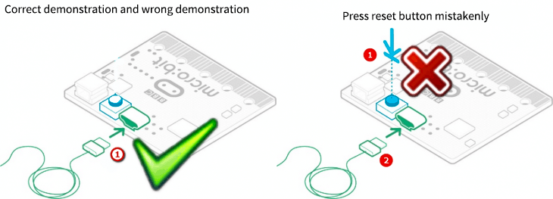

2. Don't unplug the cable suddenly during downloading micro:bit program, otherwise, the firmware will be lost and enter in“MAINTENANCE”mode

3. In the experiment, wrong wiring also cause short circuit or losing the firmware.